**INSTANCE PROVISIONING PROCESS**

Figure 1: Openstack Components while provisioning an instance:-

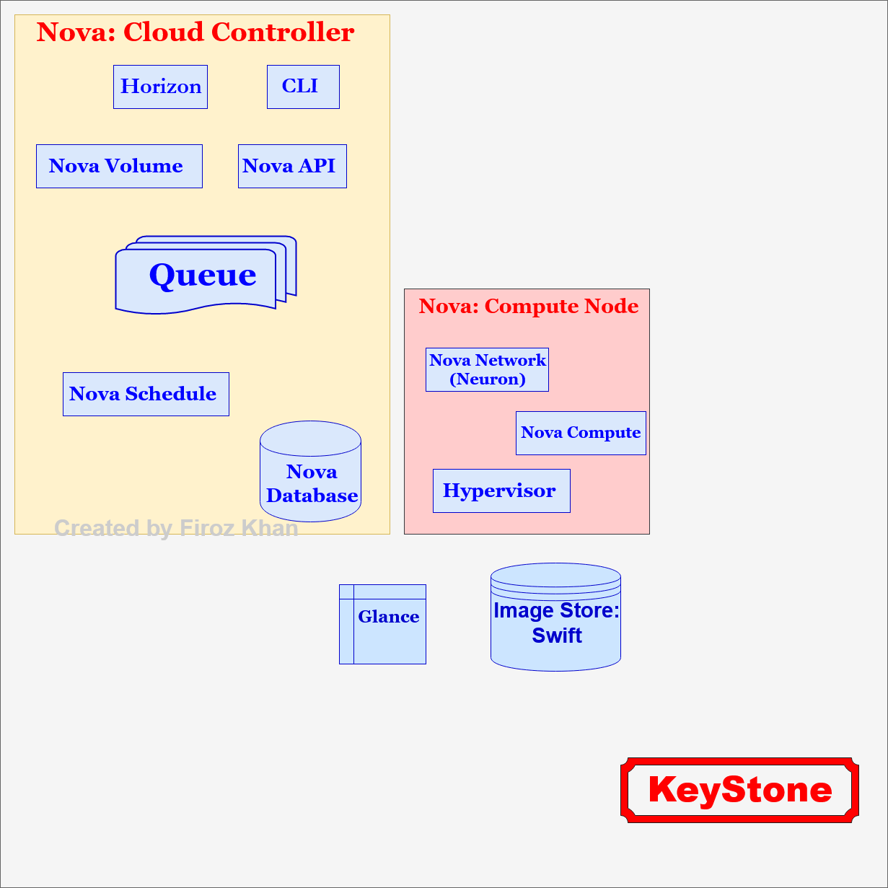

Figure 2: User Login:-

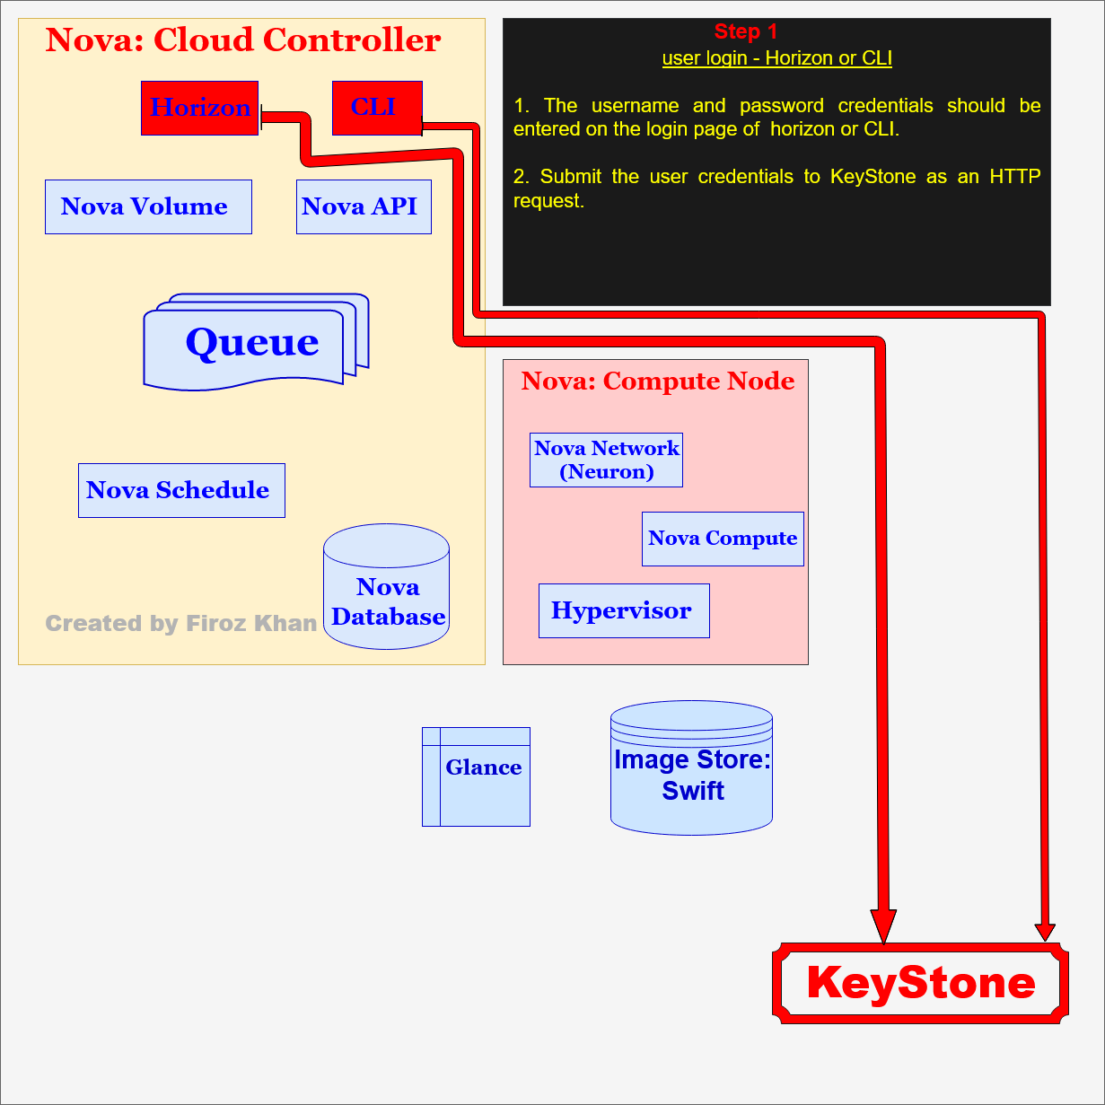

Figure 3: Validation:-

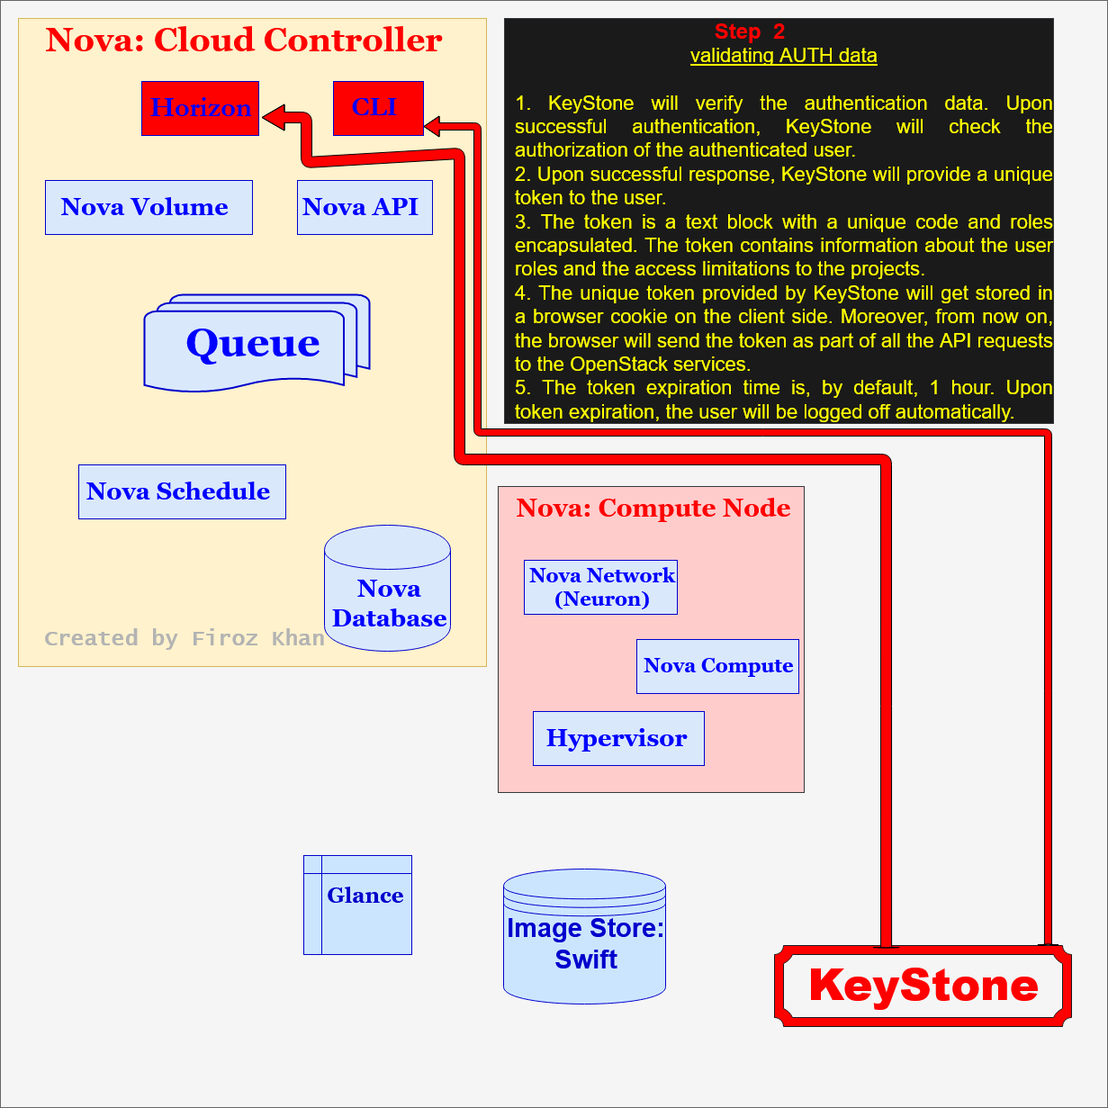

Figure 4: Sending an API request:-

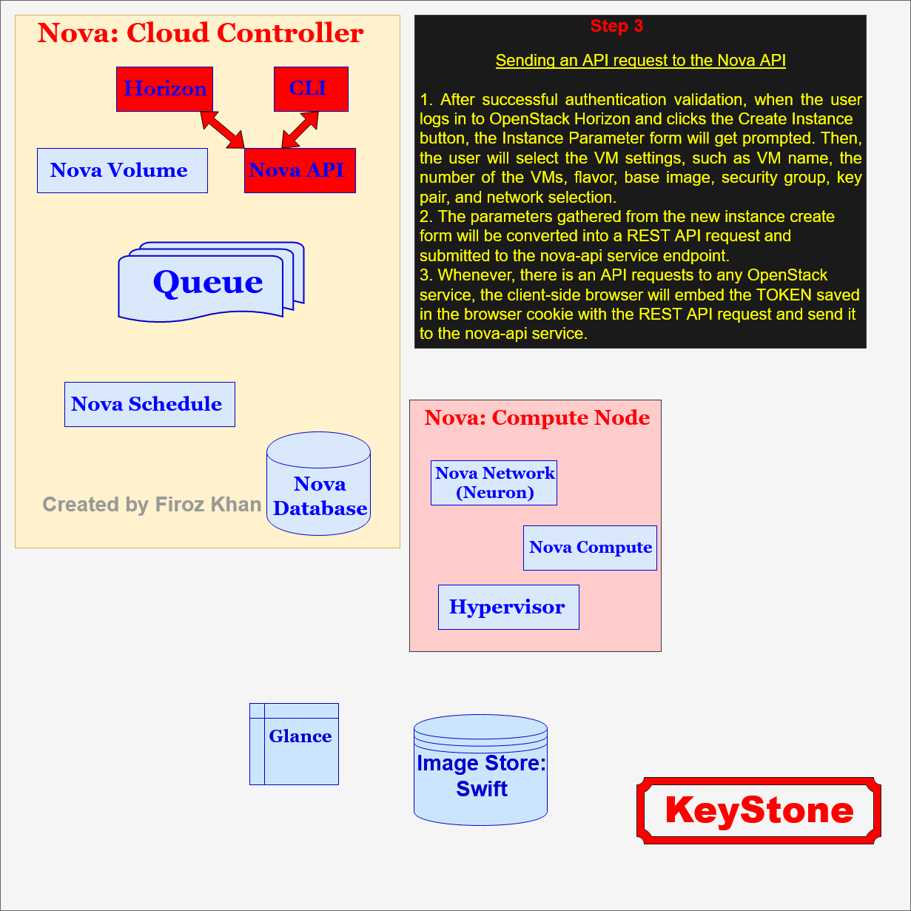

Figure 5: Validating the API token:-

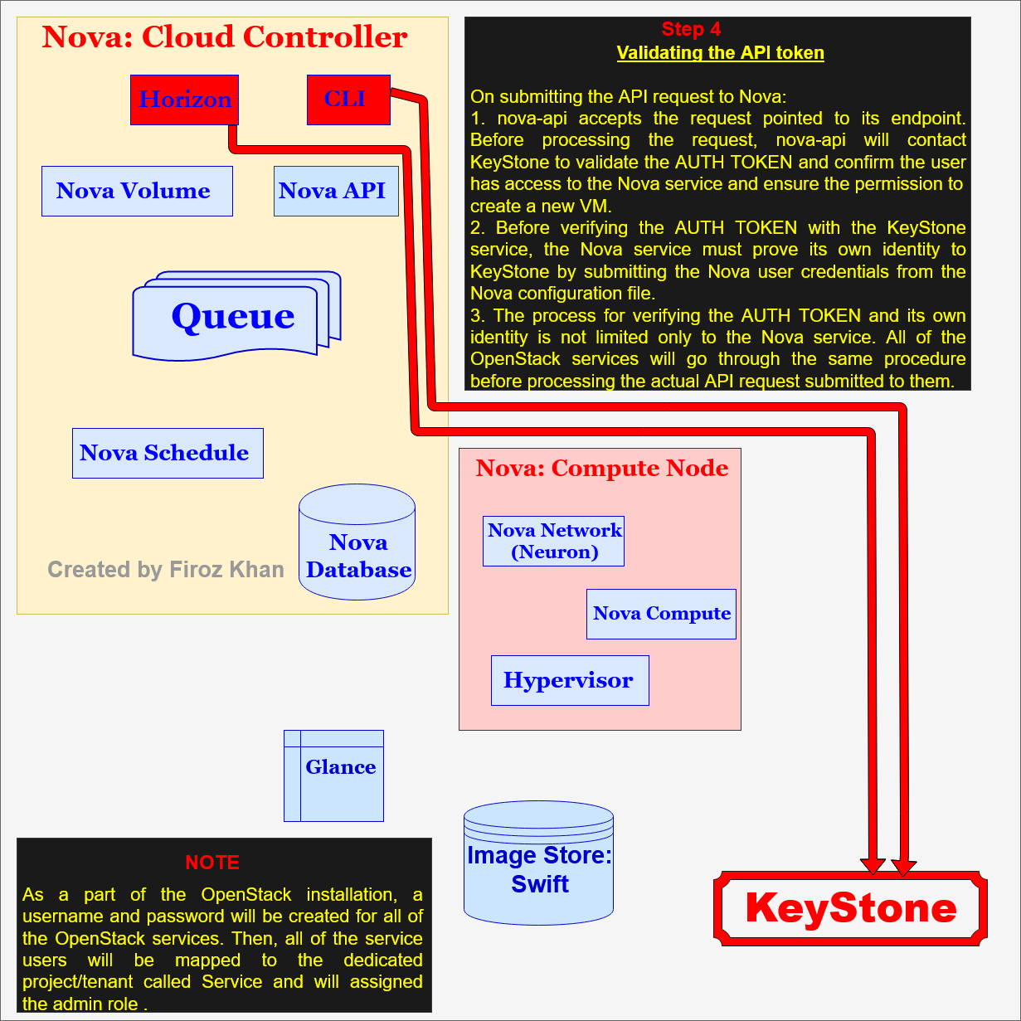

Figure 6: Processing the API Request:-

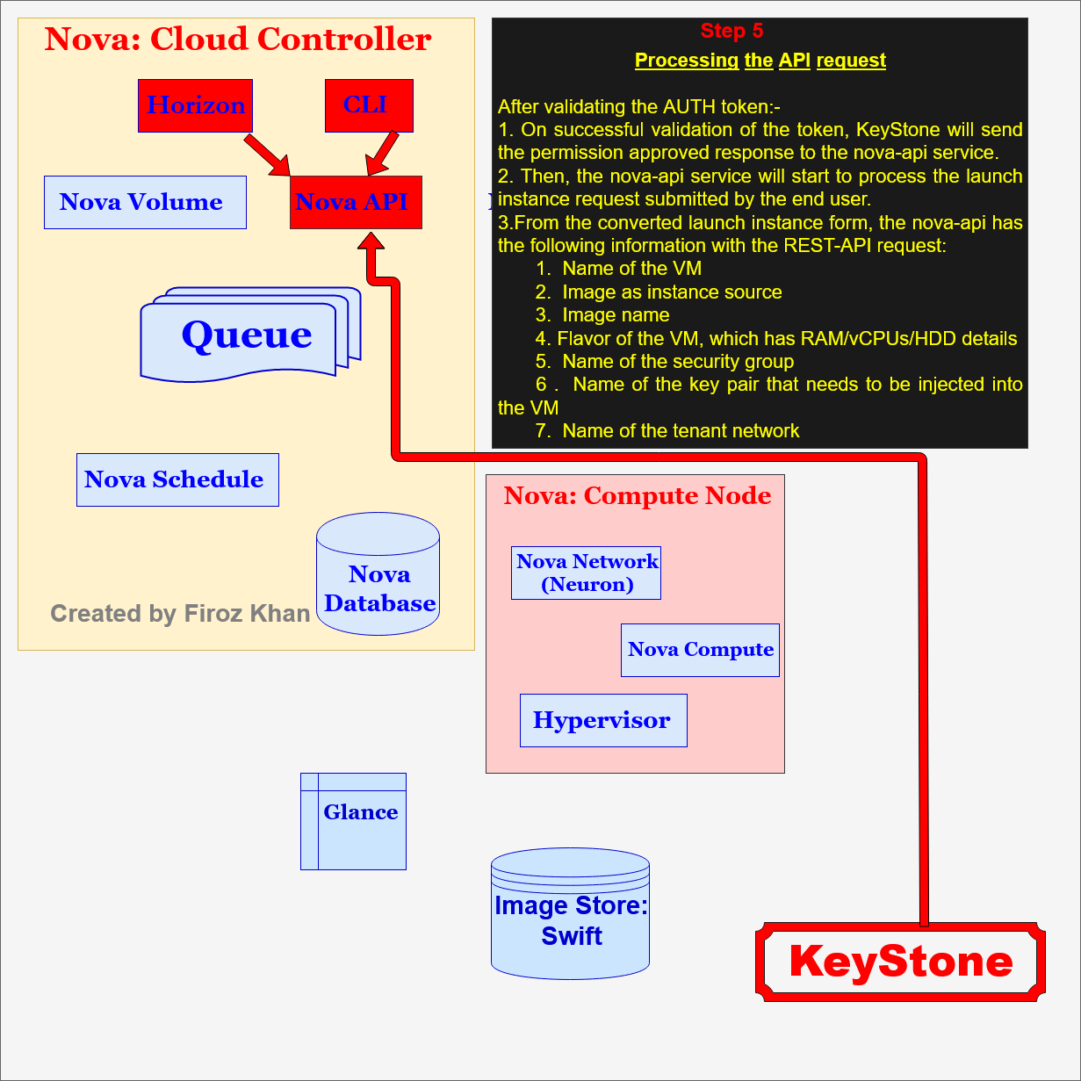

Figure 7: Publishing the provisioning Request:-

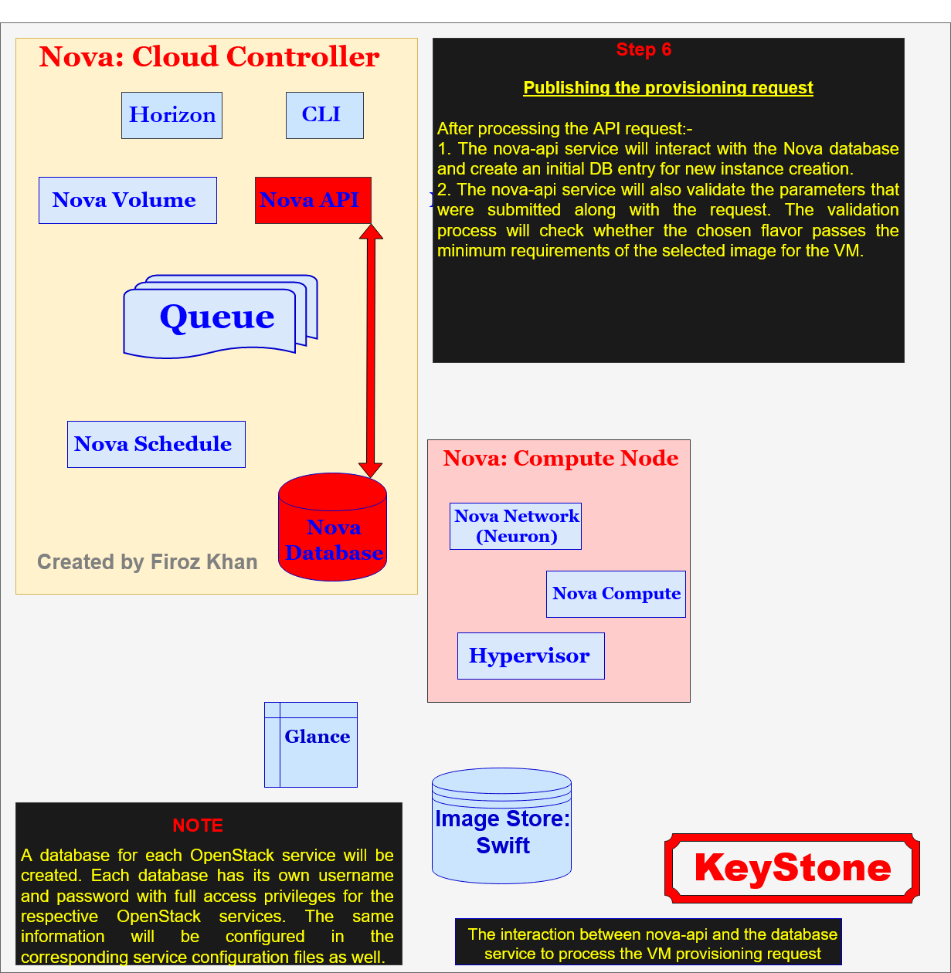

Figure 8: Picking the provisioning Request:-

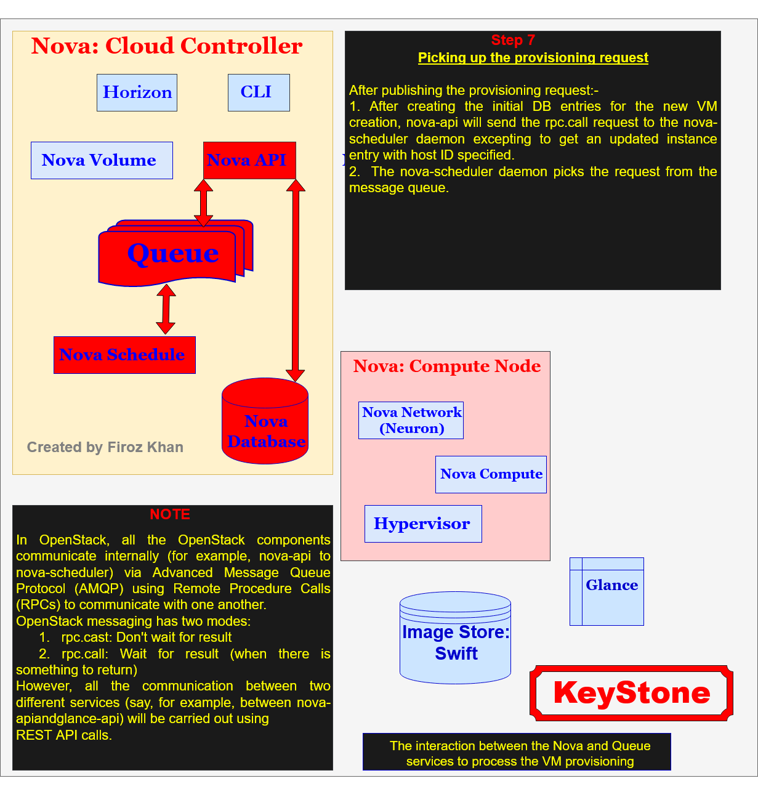

Figure 9: Filtering the VM Hosts:-

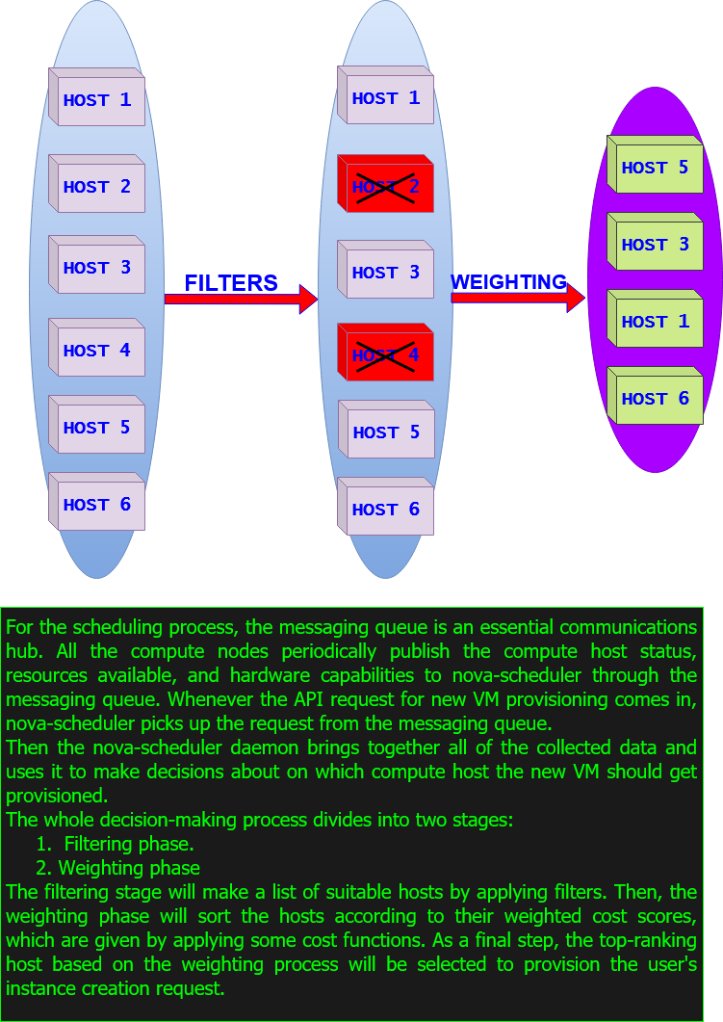

Figure 10: Schedule provisioning:-

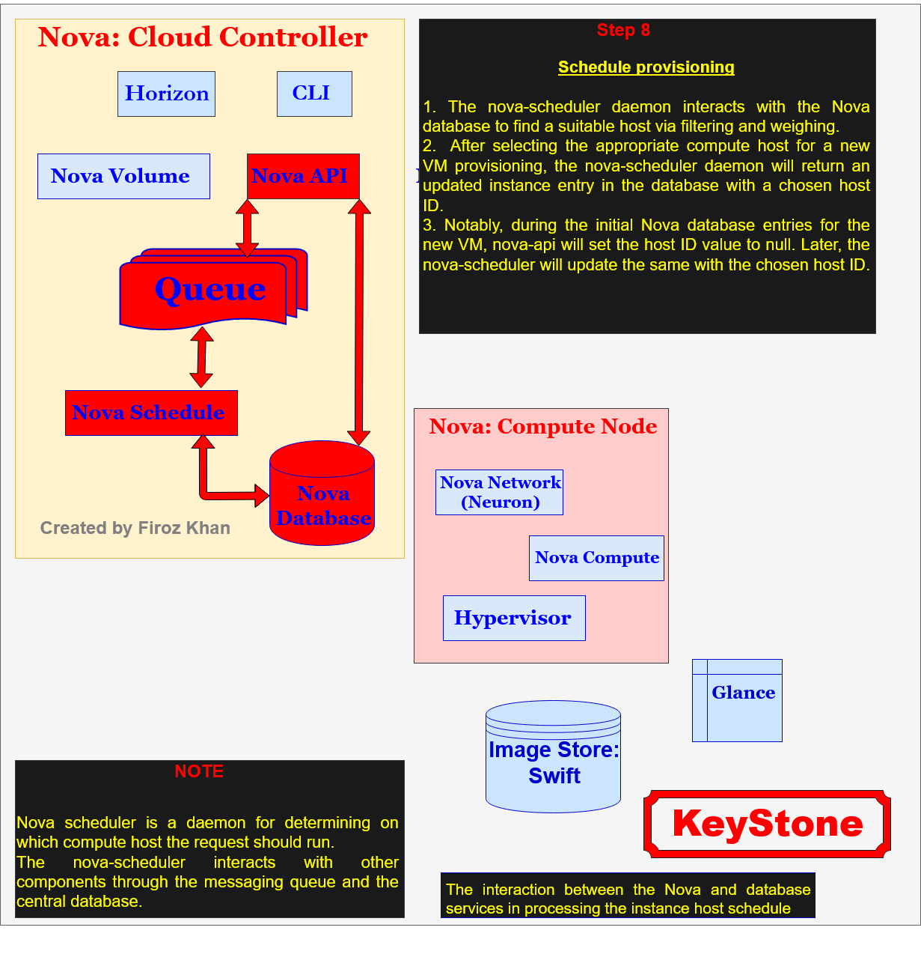

Figure 11: Starting the VM provisioning:-

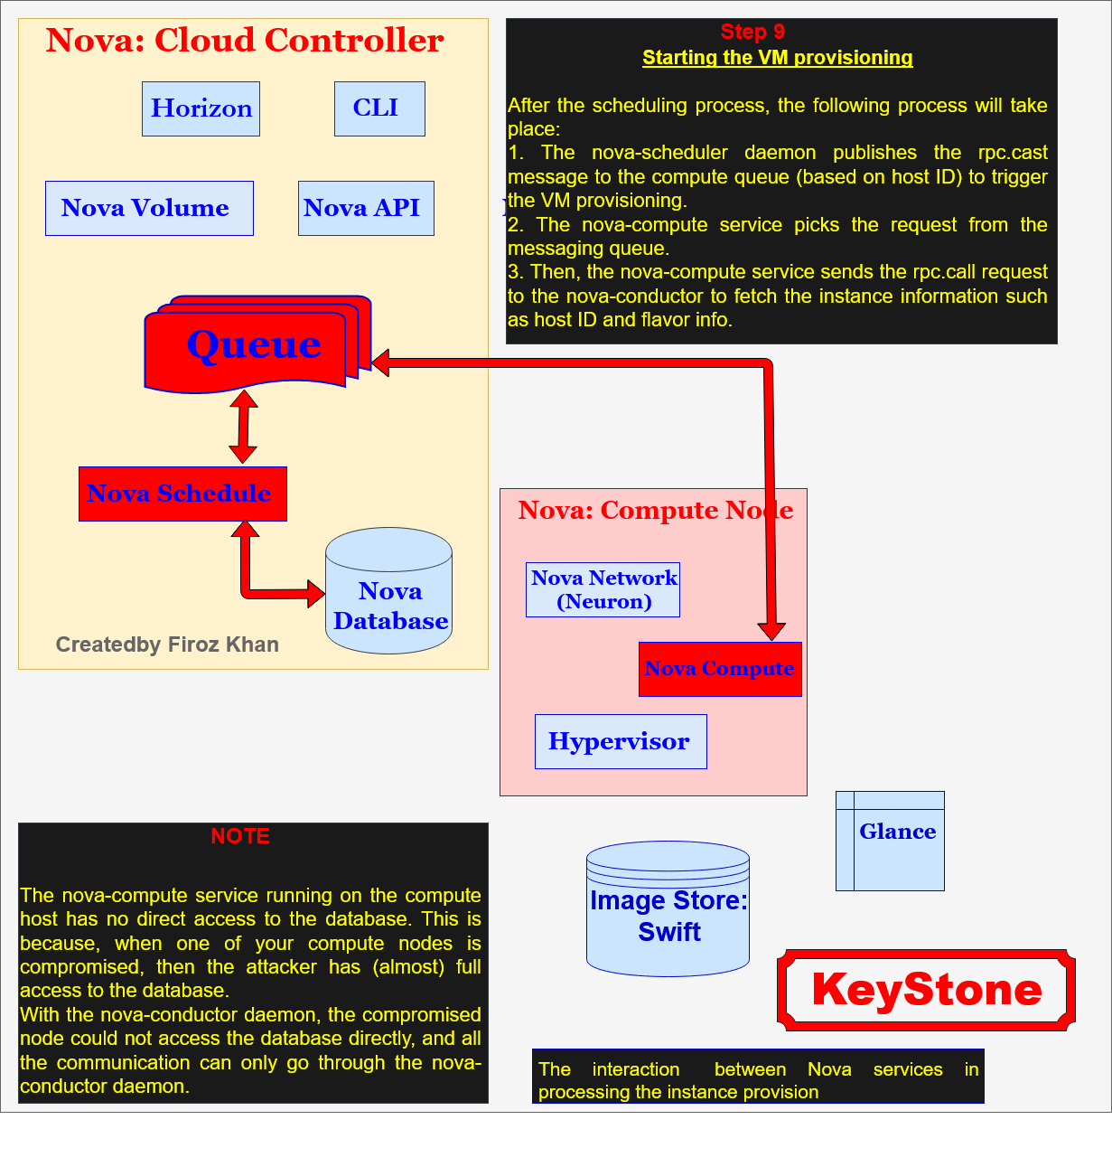

Figure 12: Starting the VM rendering via the hypervisor:-

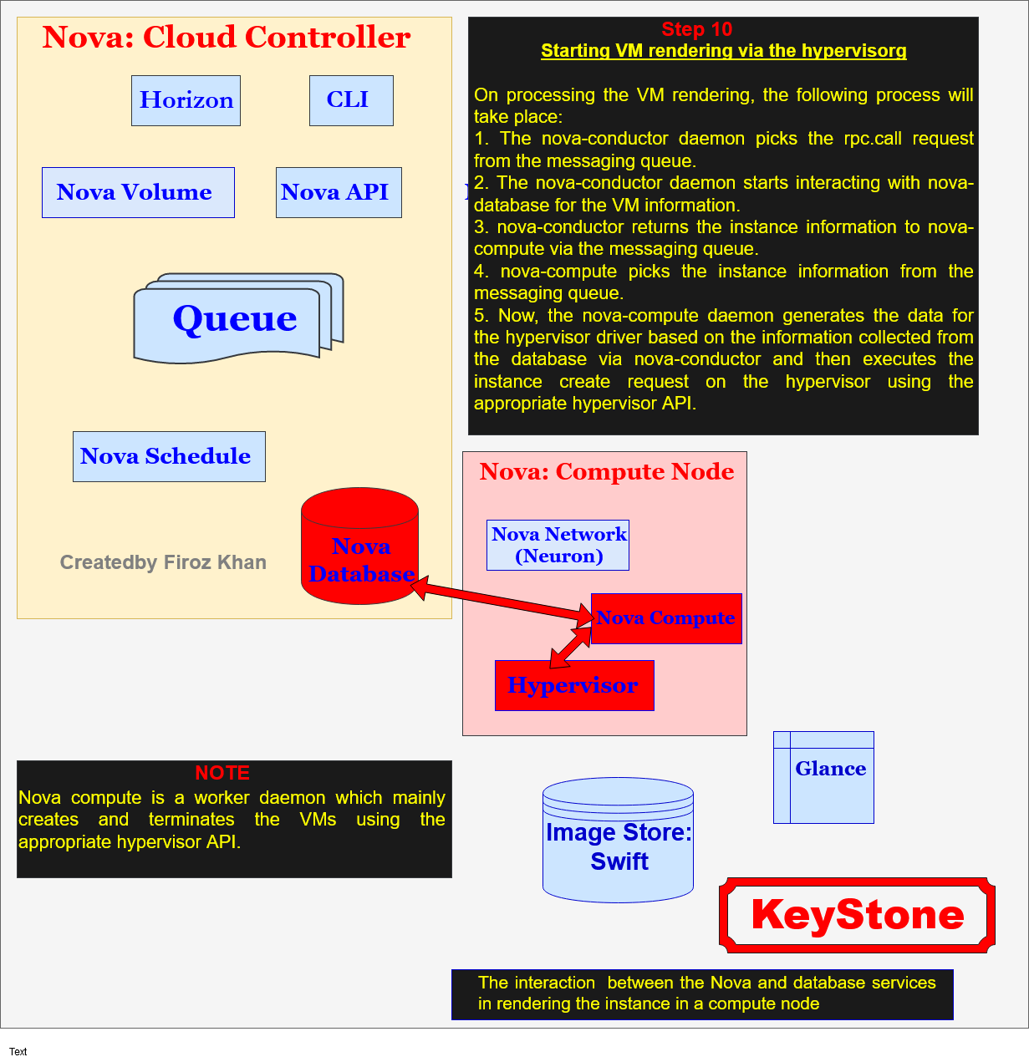

Figure 13: Requesting the base image for VM rendering:-

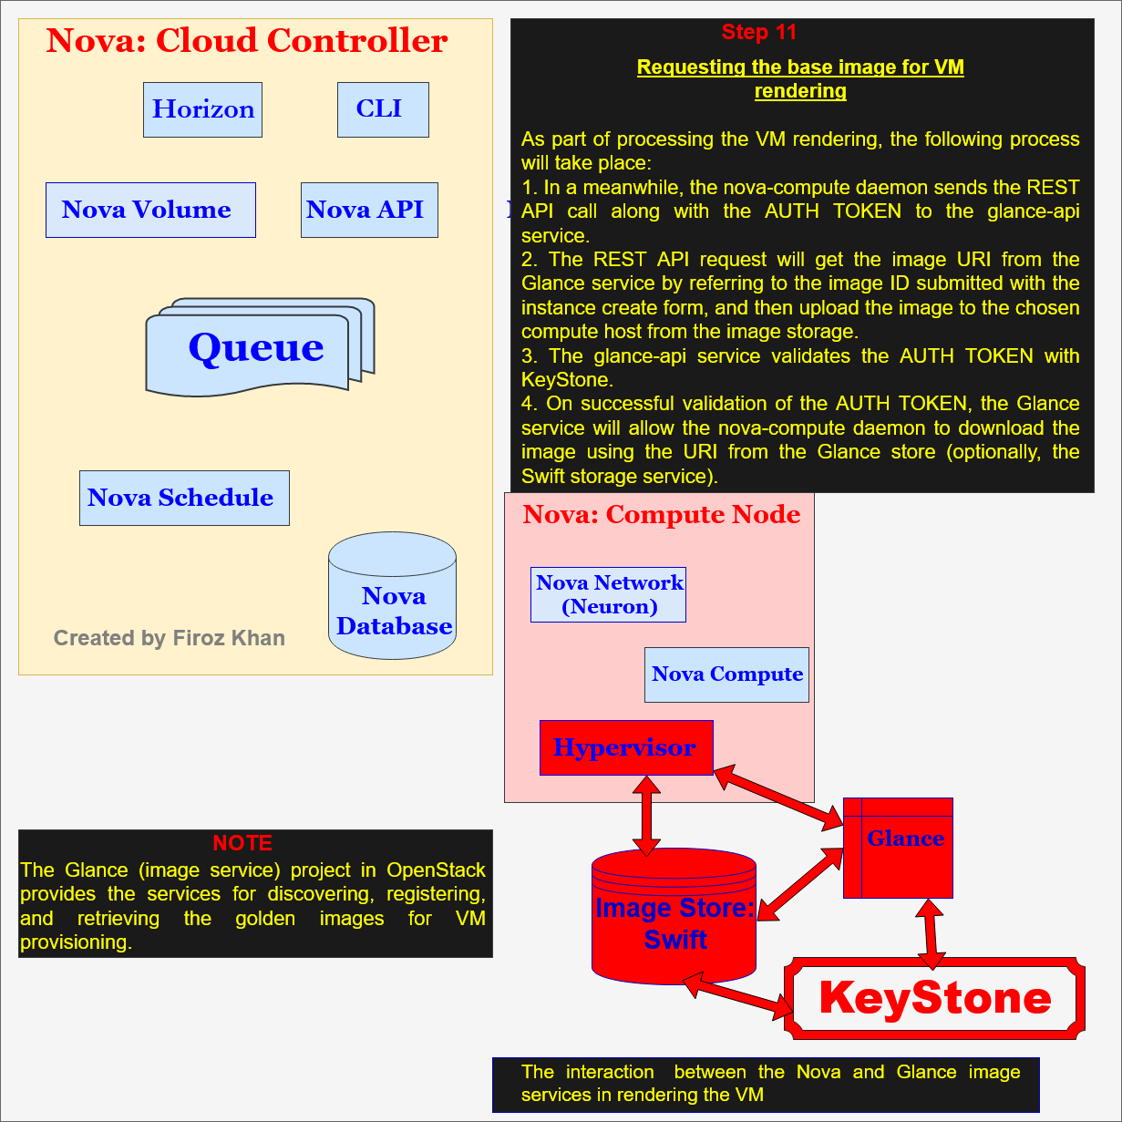

Figure 14: Configuring the network for an instance:-

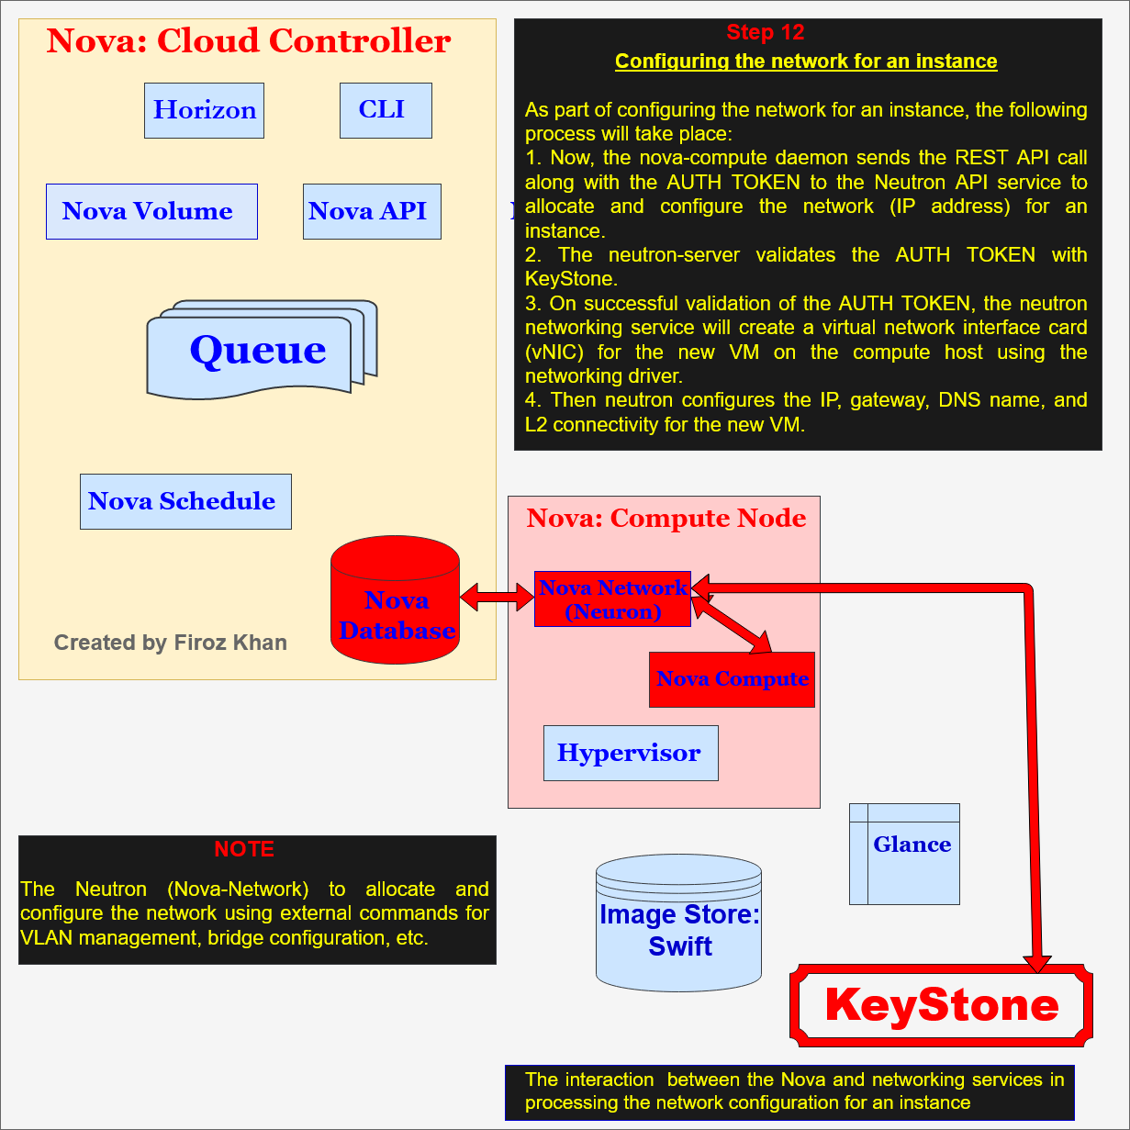

Figure 15: VM in running state:-

